Practical 4 Date Exercises

- For today’s date produce the following output to the console window using the class LocalDate, LocalTime or LocalDateTime. It is ok to just code this in an App class. Open up the JavaDoc for the LocalDate in a browser window.
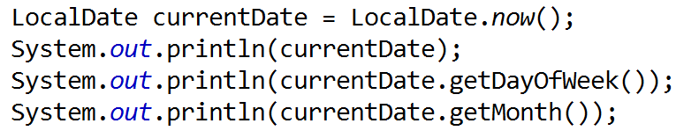

 | Data | Method | Class
YEAR | 2018 | getYear | LocalDate
MONTH | 3 | getMonthValue | LocalDate
DATE | 2018-03-05 | toString | LocalDate
DAY_OF_MONTH | 5 | getDayOfMonth | LocalDate
DAY_OF_YEAR | 64 | getDayOfYear | LocalDate
LENGTH OF MONTH | 31 | lengthOfMonth | LocalDate
LENGTH OF YEAR | 365 | lengthOfYear | LocalDate
HOUR | 11 | getHour | LocalTime
MINUTE | 3 | getMinute | LocalTime
SECOND | 46 | getSecond
AM_PM | 11:03 AM | DateTimeFormatter.ofPattern("hh:mm a"); | DateTimeFormatter
MILLISECOND | 1488146886414 | currentTimeMillis (static method)  (returns a long) | System
Month | MARCH | getMonth | LocalDate
Day | MONDAY | getDayOfWeek | LocalDate

- Using a dialog box ask the user for their birthdate. Best option: let them give you their birthdate in the form 20/01/1988 (split the string on the / symbol- then you will have an array, or use the string methods indexOf and subString to extract the numbers ). Then create a LocalDate object that takes in year, month and date.
Work out their age. It is not as simple as currentDate.getYear() – birthYear.getYear(). That’s only true for people who have already had a birthday this year.
- Set up a timer using an object of the Instant class and report how many milliseconds it took the user to enter their details. There is a Duration class that has the method call Duration.between(x,y). This elapsed object can then show time differences.
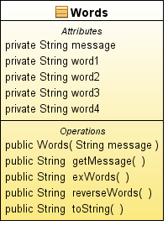
- Write a program that reads in a string containing exactly four words (separated by * symbols) into a single String property. Next, extract each word from the original string and store each word in a separate property. Then concatenate the words in reverse order to form another string. Display both the original and final strings. If you are struggling to start, use the file WordSkeleton.java to get you going
The new API specifies a number of new classes which are divided into the categories of continuous and human time. Continuous time is based on Unix time and is represented as a single incrementing number.

Class | Description
Instant | A point in time in nanoseconds from January 1st 1970
Duration | An amount of time measured in nanoseconds
Human time is based on fields that we use in our daily lifes such as day, hour, minute and second. It is represented by a group of classes, some of which we will discuss in this article.
Class | Description
LocalDate | a date, without time of day, offset or zone
LocalTime | the time of day, without date, offset or zone
LocalDateTime | the date and time, without offset or zone
OffsetDate | a date with an offset such as +02:00, without time of day or zone
OffsetTime | the time of day with an offset such as +02:00, without date or zone
OffsetDateTime | the date and time with an offset such as +02:00, without a zone
ZonedDateTime | the date and time with a time zone and offset
YearMonth | a year and month
MonthDay | month and day
Year/MonthOfDay/DayOfWeek/... | classes for the important fields
DateTimeFields | stores a map of field-value pairs which may be invalid
Calendrical | access to the low-level API
Period | a descriptive amount of time, such as "2 months and 3 days"

